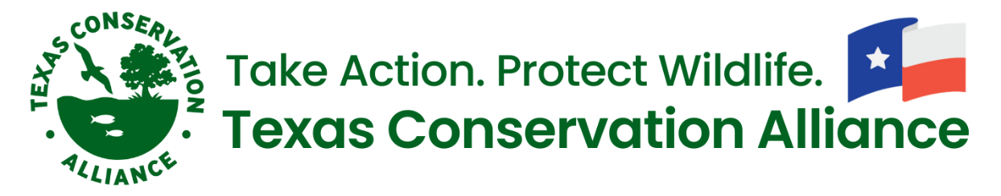
Careers in Conservation Internship Program
For which semester are you applying? SPRING SUMMER FALL
Name:
Address:
City, State, Zip:
Email:
Phone number:
Are you currently enrolled in school? Yes No
If yes, please answer the following questions:
1. School Name:
2. Major:
3. Year in school:
4. Anticipated or actual graduation date:
(Optional) Please provide one professional reference indicating: 1) Full Name; 2) Relation; 3) Contact email and phone number
What are your future career plans?
Please list three TCA projects that interest you the most (review the Internship description)
What are your expectations of an internship with TCA? Please list three things you hope to achieve.

Please email your resume and a cover letter with this completed application to Jose@tcatexas.org.

